CRASH Project
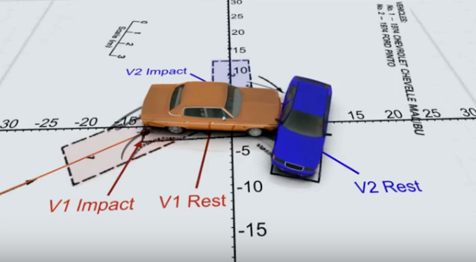
Expert analysis of accidents, kinematics and dynamics

Índex
1. The role of judicial experts 2
2. Expert Training Course 3
2.1. Level 1 Accreditation: Practice on Kinematics 3
2.2. Level 2 Accreditation: Dynamic Practice (I). 10
2.3. Level 3 Accreditation: Dynamic Practice (II) 15
3. Cas Sánchez contra Taulí. Pèrits en pràctiques. 17
4. Cas Figueras contra Carrillo. 22
5. Cas López contra Johanson 26
6. Additional tools & info 30
7. Vocabulary 31
8. Review 32
9. Avaluació 33

GROUP MEMBERS:

1. The role of judicial experts
In the event of an accident, civil consequences (payment of fines or compensation) or even criminal can be derived. On occasions drivers do not agree on the responsibility and development of the accident and a trial is reached. In the trial, the lawyers argue on behalf of their representative and defend their version. To do so, a very important role is that of scientific experts, who reconstruct accidents based on evidences (ruts, witnesses, damage to cars...), through scientific knowledge and sometimes using simulations or reconstructions of accidents.
- Look at these videos:
Vídeo 1. https://www.youtube.com/watch?v=vVq5ru8xmSM
Vídeo 2. https://www.youtube.com/watch?v=v17W-hzBt7U (only till minute 35)
- List: What do you think were the starting data of the experts to reconstruct what happened in the accident?
-
-
-
-
-
-
- Justify: Do you think their results are scientific? Do you consider that they are reliable? (Since ... because ... given that ...)

In this project you will act as scientific experts of car accidents to solve three cases. The activity will follow these stages (write down next to each point which pages it occupies in the dossier):
1) You will take an Expert Training Course.
2) You will do your training practices as experts.
3) You will analyze a case as expert in practices.
4) You will analyze two cases autonomously.
5) You will declare yourself in a trial as an expert.

2. Expert Training Course

2.1. Level 1 Accreditation: Practice on Kinematics
In this practice, we will work on the representation of the movement and concepts such as Position, Movement, Speed, Distance, Direction, Sense, Starting point, Endpoint, Acceleration, Initial Speed, Final Speed. These data must be recorded in your reports as an expert when you analyze the cases. When a specialist makes an error communicating their analysis, this greatly harms the client's position in the case, so it is essential that you learn to make a correct interpretation and use of the physical magnitudes used to describe and study the movement, what is called Kinematics.
Step A: Procedure
For this practice you will work in groups, using common areas. It is of great importance not to disturbe other classes, keeping your voice at an appropriate level and working seriously. This will be considered for evaluation. Every group will need a timer (you can use a phone phone)
• From a starting point (origin), measure with the tape and mark in a straight line marks at distances of 0, 5, 10 and 15 meters.
• Each member of the group will take the route from the point of origin to the point of arrival (15 meters). One will do it on one foot (lame footer), the other one walking fast and the third running. Pact who will do each type of route.
• While a colleague does the tour, the other two record the time that the they takes to pass through each of the points.
• Repeat the measure for a total of two times. Write the measurements on the table below and calculate the average (shaded).
 | 0m | 5 m | 10 m | 15 m
Lame footer | 0 s
Lame footer | 0 s
Lame footer | 0 s
Walking | 0 s
Walking | 0 s
Walking | 0 s
Running | 0
Running | 0 s
Running | 0 s

- Represent graphically all three movements identifying every line corresponding to the lame footer, walking or running.
t

- Look at the graph and answer: which line is steeper (més pendent)?

- Answer and Justify. If you see a graphic that is very steep, we have to consider:
- It is going very fast
- That it is going very slow
Because..

- Complete:
Considering our knowledge, we can say that the slope of these graphs represents: ......................
Therefore, a flat graph (without slope) means that: ............................

- Calculate. Speed can be calculated by dividing the space traveled (S) by the time (t). Calculate for each movement the speed in m/s and also in Km/h, using scaling factors.
Movement | Speed in m/s | Speed en Km/h
Lame footer
Walking
Running

- Compare the speeds obtained with those of these other animals, sort (ordena) them from highest to lowest, including those of your classmates.

Snail: 0.05 km / h
Human walking: 4 km / h
Human swimming: 6 km / h
Spider: 1.8 km / h
Running human: 26 km / h
Elephant: 40 km / h
Velociraptor: 60 km / h
Horse: 70 km / h
Cheetah: 115 km / h
Eagle: 300 km / h
Growth speed of the nails: 0.00000004 km/h
Fruit fly: 0.7 km / h

Sort here (use the mathematical symbol >)
Eagle >

Step B
Procedure
Now we use the same space references (distances of 5, 10, and 15 meters), but every member of the group will do the following two routes:
- Vamoquenovamo: start slowly and go faster.
- YaMeCansao: start very fast and slow down until you reach the end

- Complete the measurements table. Write the values ​​for each type of route. No need to make averages.
 | 0m | 5 m | 10 m | 15 m
Vamoquenovamo | 0 s
Vamoquenovamo | 0 s
YaMeCansao | 0 s
YaMeCansao | 0 s

- Represent graphically the two movements (Vamoquenovamo in blue and Yamecansao in another color). There should be a total of 6 lanes, one for each movement in the table.
t

- Describe the graphics (instead, in comparison, on the other hand, ...).

- Respond and Justify: If you see that a graph is curved upwards, we have to consider:
- That movement is becoming faster.
- That movement is slowing down.
Because...

- Answer: What effect do you observe in the graphs according to the type of movement?

- Complete: With what we know, we can say that the upward or downward curb represents: .............................

- Associate and Justify: If you had to choose, what association would you do?
Vamoquenovamo, Yamecansao, accelerated movement, positive acceleration, negative acceleration.

Step C
- Look at the chart below and answer:
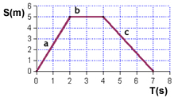

What happens between seconds 0 and 2?
And between the second and fourth seconds?
And between the second 4 and 7?
What is the speed in the first stretch?
And in the second?
And in the third?
- Graphic representation
For each of the following tables, do the following exercises:
1) Represent the graphic that corresponds to the table.
2) Say in what section of the movement:
- The object is farther from its origin.
- The object moves at a faster instantaneous speed.
- The object does not move.
- The object move backwards.
3) Explain, with your words, the movement that the object makes.
4) Calculate the displacement (d = S_{f}-S₀) and, when calculated, calculate the overall average speed of each object (v = d / t).
Graphic 1
S[m] | 0 | 4 | 9 | 9 | 15 | 14 | 10
T[s] | 0 | 2 | 5 | 7 | 8 | 12 | 15
Graphic 2
S[m] | 0 | 3 | 7 | 6 | 15 | 14 | 10
T[s] | 0 | 1 | 6 | 7 | 8 | 12 | 15
Graphic 3
S[m] | 8 | 6 | 4 | 4 | 10 | 15 | 15
T[s] | 0 | 2 | 5 | 8 | 10 | 12 | 13
Graphic 5
S[m] | 15 | 13 | 8 | 3 | 2 | 1 | 0
T[s] | 0 | 2 | 4 | 5 | 10 | 12 | 15
Graphic 6
S[m] | 5 | 5 | 15 | 15 | 4 | 3 | 0
T[s] | 0 | 3 | 5 | 6 | 7 | 10 | 15

2.2. Level 2 Accreditation: Dynamic Practice (I).
One of the things involved in accidents is the braking distance. There are several things that influence it: the driver's reaction time, the quality of the brakes… but especially the adherence of the tires and the friction with the ground. Therefore, when there is ice or water (which reduces friction) there are usually more accidents. Experts must take into account the possibility of poor condition of the road or tires in the reconstruction of accidents, as this affects the braking distance.
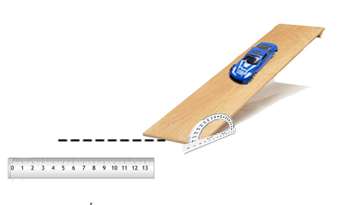
In this practice we will work with experimental models made up of toy cars that will accelerate with ramps, so that their own weight will act as a driving force. These experimental models are the ones that we will use to analyze the Cases later.

We will study the braking distance of cars (from leaving the ramp until it stops), depending on the impulse and the type of roadway. To do this, we will launch the cars at different speeds (depending on the incline of the ramp) and measure the braking distance on different surfaces.

Procedure:
• Using a protactor (transportador d’angles), adjust the ramp to a certain slopen (note the degrees). Each team needs to study two different slopes of ramp, between 10 and 50 °.
• Make three releases and measure the braking distance of each launch, using a measuring tape or ruler. You should measure the distance from the ramp’s end to the position where the rear wheel stops. Calculate the average of the results in each case.
• Test three different surfaces of type of roadway (table, rubber, paper, ...) and will measure the braking distance in each case.
• Calculate the coefficient of friction of each type of surface as the % of braking distance (distància de frenada) from that obtained on the "Table" surface.

The % of braking distance represents the proportion of the standard braking distance (Table) is obtained in each case. It is calculated by dividing the braking distance / braking distance in the Table and multiplying by 100. It represents the % of the normal braking distance runs through the car before braking.

- Complete the table with the values ​​you obtain:
Slope  (Inclinació): | Mesure 1 | Mesure 2 | Mesure 3 | Average | % braking distance  coeficient de fricció
Floor |  |  |  |  | 100%

- Change the slope of the ramp. Complete the table with the new values ​​you obtain:
Slope  (Inclinació): | Mesure 1 | Mesure 2 | Mesure 3 | Average | % braking distance  coeficient de fricció
Floor |  |  |  |  | 100%

- Compare (in contrast, larger, in comparison, ...) the results obtained in both experiences. Explain them using the terms acceleration, speed (because, considering that, since ...).

- Now complete the data with those of the different groups, ensuring that they are arranged according to the slope.
Floor
Degree | Average | % | Degree | Average | % | Degree | Average | %

- Represent the % of braking in relation to the slope using a dot plot (diagrama de punts). Make a different graph of points for each surface.
Dot plots are graphs that represent relationships between two dimensions. They allow to identify tendencies in the data.
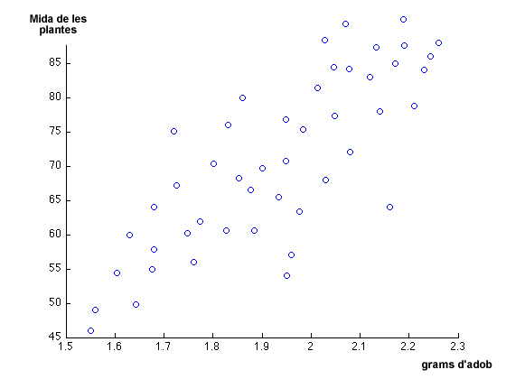 | As you can see, not all points fall into a line, but some are positioned so that a trend line (línia de tendència) could be formed.  A trend line is a line that is as close as possible to the set of points.
- Draw the trend line of this graph.
- What happens in general with the size of the plants when adding more fertilizer?
□ It increases □ It diminishes □ It stays the same
3) Complete the plot by inventing new points that make the prediction more reliable.

- Represent here the three point graphs (one per each surface). You may use excel.

- Analyze now the average braking distance by comparing the three surfaces. Are the results equivalent? Justify why (because, therefore, accordingly ...) using the data.

- Is the effect of friction the same for different speeds (different slopes of the ramp)? Justify why (because, therefore, accordingly ...) using the data.

- Discuss and conclude what has a greater effect on braking distance: friction or speed (slope)?

- Write down what you learned in this practice that you will have to take into account in your work as an expert. Write down the list of vocabulary at the end of the dossier.

2.3. Level 3 Accreditation: Dynamic Practice (II)
You have seen in the previous practice that the speed and the friction affect the braking distance and, therefore, the possibility of accidents. In this practice you will investigate the effect of mass in the braking distance.

- Can a bus be stop like a car, when they have so different masses? Why? How is called this effect?

Procedure
In this practice you will have to design your tests and choose the data you collect to answer the question. The materials that you have are the ramps, the cars, the screws (cargols) to give mass (ballast, llast) and adhesive rubber to attach the screws to the cars.
You need to represent your data in a table and a chart and answer the questions:

- What effect has the mass over the braking distance?

- Does this effect depend on friction?

3. Cas Sánchez contra Taulí. Pèrits en pràctiques.
Ara farem una primera investigació tots junts per aprendre a fer la tasca d'un pèrit. Seguim els passos:
1: Llegir bé la fitxa policial: Hi ha alguna cosa que no quadra? Quina és la impressió inicial?
2: Intentar reproduir l'accident amb les rampes, els cotxes i els llasts. Variar les condicions de velocitat, massa, fregament, fins que aconseguim reproduir el relat d’algun dels testimonis, o almenys, demostrar que és impossible algun dels relats.
3: Decidir quina és l'explicació més plausible i enregistrar la reproducció de l'accident en vídeo. Representar amb l’ajut de vectors (fletxes) la direcció i magnitud de la velocitat segons la nostra reconstrucció de l’accident.
4. Completar la fitxa d'anàlisi pericial.
5. Com a eina d’anàlisi addicional, pot ser-te útil el laboratori virtual de col·lisions, per veure modificacions de direcció segons els angles d’impacte i les masses dels cossos. https://phet.colorado.edu/sims/collision-lab/collision-lab_en.html

Lèxic Clau: #Vector, #versemblant, #nivell de certesa, #coherent, #discrepància.

Un cop hàgiu completat el cas de pràctiques, resoleu els altres dos de manera autònoma. Al final de l’activitat, sereu convocats a un judici on es llegiran els testimonis i haureu de fer una presentació del vostre peritatge.

Fitxa policial:
CODI DE SINISTRE: 030117-001 |  | ESCENARI
Testimoni 1:  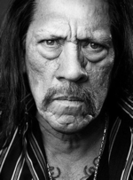  S.Sánchez | Conductor cotxe blau.  “Ella iba mirando el móbil. Se incorporó sin mirar y me golpeó el costado de la furgoneta. Iba más rápido que yo. Perdí el control y acabé chocando con la farola”. | 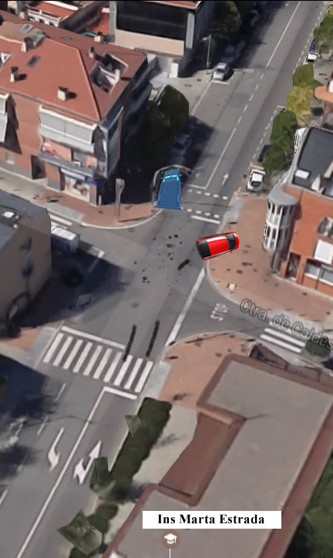  Visitar l'espai a Google Maps per analitzar millor la situació:  Coordenades GPS: 41.612731, 2.279004
Testimoni 2:  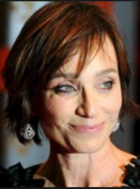  E. Taulí | Conductora cotxe vermell.  “Em vaig incorporar, no venia cap cotxe i de cop i volta vaig sentir una frenada i un impacte molt fort. No sé d'on havia sortit, anava més ràpid que jo”.“
Testimoni 3:  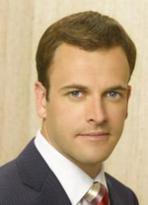  F.Grabulosa | Peató  “No vi el accidente, pero sí a los dos coches antes de que se produjera. La furgoneta azul iba más rápido que el coche rojo. No sé si frenó más tarde.”
Característiques vehicles:  Cotxe Blau: TARA: 2600 Kg.  Cotxe Vermell TARA: 1600 Kg. |  | Danys i impactes:  Sense dades
Anàlisi Pericial
Procés de recerca
Com que...Hem provat...i els nostres resultats han estat....Per tant, hem decidit que...A continuació, en un tercer pas,....

Condicions finals versemblants:
Gràfic a t= -1 |  | Gràfic a t= 0
Gràfic s/t Vehicle 1 |  | Gràfic s/t Vehicle 2
N'estem molt/poc segurs, perquè...

Per millorar el greu de certesa, ens caldria....
Preparació de la declaració al judici

- Presentació d'evidències

- Reconstrucció de l'accident. (Vídeo + vectors).

- Presentació de conclusions i determinació del grau de certesa.

4. Cas Figueras contra Carrillo.
CODI DE SINISTRE: 030117-002 |  | ESCENARI
Testimoni 1:    A.Figueras | Conductor furgoneta blava.  “Jo circulava a velocitat moderada i de cop i volta vaig sentir un impacte molt fort. Quan vaig recuperar el coneixement, vaig veure que m'havien envestit pel darrera” | 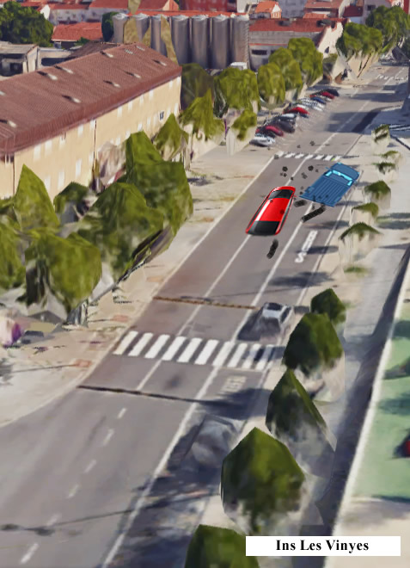  Visitar l'espai a Google Maps per analitzar millor la situació:  Coordenades GPS: 41.480557, 1.982115
Testimoni 2:    I.Carrillo | Conductora cotxe vermell.  “Ell estava aparcat. Es va incorporar a la carretera sense mirar i no vaig poder fer res per a evitar-ho, tot i que jo anava més poc a poc que ell”.
Testimoni 3:  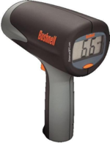 | “El radar de velocitat mostra que el cotxe vermell anava molt més ràpid que el cotxe blau”.
Característiques vehicles:  Cotxe Vermell TARA: 1200 Kg.  Cotxe Blau: TARA: 2400 Kg. |  | Danys i impactes:  Sense dades

Anàlisi Pericial
Procés de recerca
Com que...Hem provat...i els nostres resultats han estat....Per tant, hem decidit que...A continuació, en un tercer pas,....

Condicions finals versemblants:
Gràfic a t= -1 |  | Gràfic a t= 0
Gràfic s/t Vehicle 1 |  | Gràfic s/t Vehicle 2
N'estem molt/poc segurs, perquè...
Per millorar el greu de certesa, ens caldria....

Preparació de la declaració al judici

- Presentació d'evidències

- Reconstrucció de l'accident. (Vídeo + vectors).

- Presentació de conclusions i determinació del grau de certesa.

5. Cas López contra Johanson
CODI DE SINISTRE: 030117-002 |  | ESCENARI
Testimoni 1:  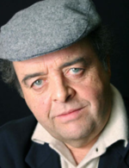  F. López | Conductor taronja:  “Yo circulaba por la calle Andreu Febrer. Ella venía más rápido que yo y no vió que venía, se incorporó muy rápido por la derecha de golpe justo cuando pasaba yo, no me dió tiempo ni a frenar.” | 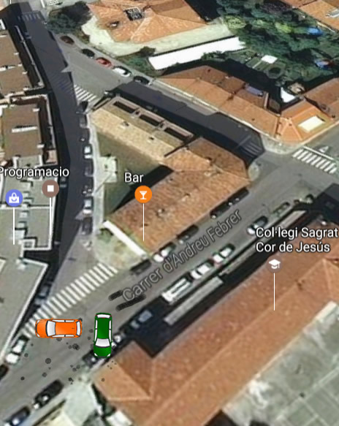  Visitar l'espai a Google Maps per analitzar millor la situació:  Coordenades GPS: 41.925228, 2.254551
Testimoni 2:  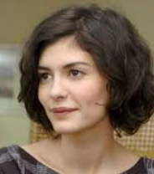  O. Johanson | Conductora Verd:  “He drived really very fast, much more than me, and I wasn’t able to avoid the impact. I'm so sad for him. You know, elderly people aren't always able to drive properly”.
Testimoni 3:  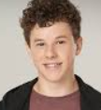  P.Costa | Alumne sortint de l'escola:  “El cotxe verd anava més ràpid que el taronja. Vaig sentir una frenada i de cop i volta vaig veure el cotxe verd que venia cap a mi i xocava amb la porta”.
Característiques vehicles:  Cotxe taronja: TARA: 1200 Kg.  Cotxe verd: TARA: 1800 Kg. |  | Danys i impactes:  Cotxe taronja: Paraxocs posterior esclafat. Cotxe verd: paraxocs davanter esclafat.

Anàlisi Pericial
Procés de recerca
Com que...Hem provat...i els nostres resultats han estat....Per tant, hem decidit que...A continuació, en un tercer pas,....

Condicions finals versemblants:
Gràfic a t= -1 |  | Gràfic a t= 0
Gràfic s/t Vehicle 1 |  | Gràfic s/t Vehicle 2
N'estem molt/poc segurs, perquè...

Per millorar el greu de certesa, ens caldria....
Preparació de la declaració al judici

- Presentació d'evidències

- Reconstrucció de l'accident. (Vídeo + vectors).

- Presentació de conclusions i determinació del grau de certesa.

6. Additional tools & info
In this section you will find tools and information that can help you improve your work. Its use is optional.

1) Braking distance:
http://revista.dgt.es/es/multimedia/infografia/2015/0706-Distancia-reaccion-y-frenado-campo-futbol.shtml#.WsnNyCOLQnU

2) Impact simulator (you can set the mass and speed, to experience the resulting angle of the composition of forces in the impact).
https://phet.colorado.edu/sims/collision-lab/collision-lab_en.html

3) Google Maps https://www.google.com/maps

7. Vocabulary
It is the [category] that ... [description of fundamental characteristics]. Complies ... [Description of non-essential features]. Here are examples ... [Examples]

8. Review
- Respond Individually:
a) What data do you think that the experts on the movement and the cars need to reconstruct the accident?

b) Do you think that your results are scientific? Do you think they are reliable?

c) What are the most important things you learned in the course of expert training?

d) What are the most important things you learned in the resolution of cases?

9. Avaluació

Autoavaluació treball equip de pèrits
Data -->

Alumne/a

Coavaluació Declaració al Judici
Equip -->

Criteris
Les evidències s'expliquen amb claredat
S'explica bé el procés seguit per a reproduir l'accident, usant adequadament lèxic i conceptes físics.
El vídeo-reconstrucció es justifica adequadament amb vectors i lèxic.
Les conclusions queden clares i es justifica bé el nivell de certesa.

Avaluació de l'informe pericial (Dossier)
 | 1 | 2 | 3 | 4
Està complet
Presentació i ortografia completes
Justificacions i argumentacions correctes
Ús correcte del lèxic
Representació vectorial

Crèdits
El projecte CRASH és el resultat d'una idea original co-creada a la trobada #betacamp16 per el node de professorat #TauronsIndagadors http://www.betacamp.cat/taurons-indagadors/ i ulteriorment desenvolupada per professors del grup de treball EduWikiLab https://eduwikilab.wordpress.com/ i de l’Institut Marta Estrada.
Han participat en el seu desenvolupament els professors/es Elisa Goytia, Jesús Gasco, Santi Vilches, Elena Fonalleras, Anna Casals, Eulàlia Serrano, Anna Saperas, Gemma Ventura, Jordi Domènech, Pere Royo, Quique Vergara, Clàudia Cullell, Marcos Adelantado, Maria Cros, Javi Moreno.
La present adaptació i traducció parcial ha estat realitzada per Silvia Rodriguez-Mulero.

