Worksheet Fossils 4

Fossils can be used as markers of periods: If we find a fossil characteristic of a geologic period in a geologic structure, it is indicative of the age of the structure.
When we observe strange distributions of fossils (distributed in continents, just in one part of a continent,...) it may be indicative of ancient positions of the continents, before the action of continental drift. Taking as a reference the age of the fossils, we can determine when these changes have been produced, and the direction of these changes.

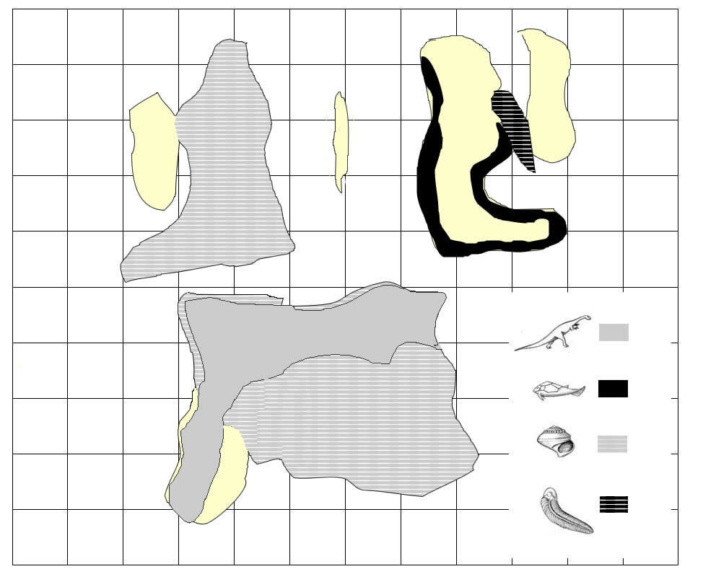
From the evidence...  (description, situation and identification of evidences) | We conclude that probably...  (what these evidences suggest or indicate) | And so...is...because/even if...also/but... (implications for the general model and connection to other evidences )
What remains unexplained...It is still to be known... (new questions arising from your conclusions, which kind of data could help you to solve it)

