Worksheet Rock Types

Depending on its origin, rocks can be classified in three types:
Metamorphic rocks are originated by the application of strong tensions and high temperatures to other rocks, usually due to tectonic efforts of compression.
Sedimentary rocks are the result of the dipositation and compactation of materials.
Igneous rocks are the result of cooling liquid magma from the inner layers of earth when exposed to the low temperatures of the surface (volcanoes, dorsals,...).

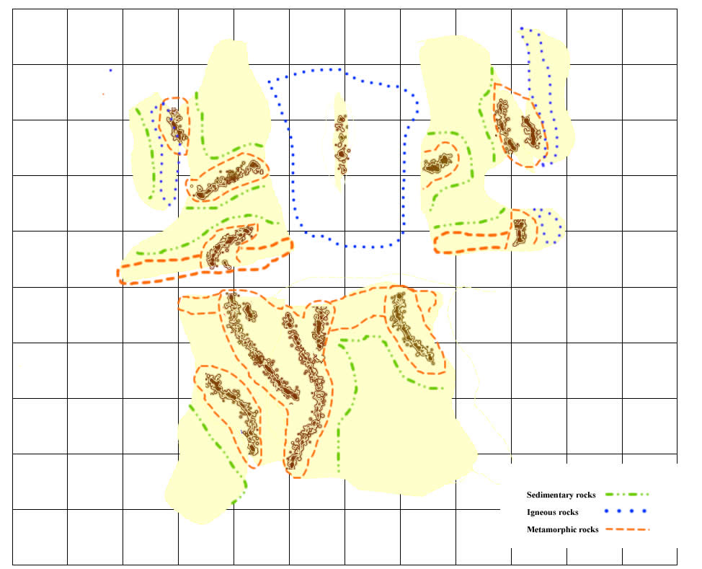
From the evidence...  (description, situation and identification of evidences) | We conclude that probably...  (what these evidences suggest or indicate) | And so...is...because/even if...also/but... (implications for the general model and connection to other evidences )

