Worksheet Seismic and Volcanic Zones

Seismic and Volvanic zones are usually correlated to tectonic events.
The different kinds of plate edges and its ubication (continental, oceanic) result in different observable events that can be used to determine the probable position of plate edges and its respective movements.

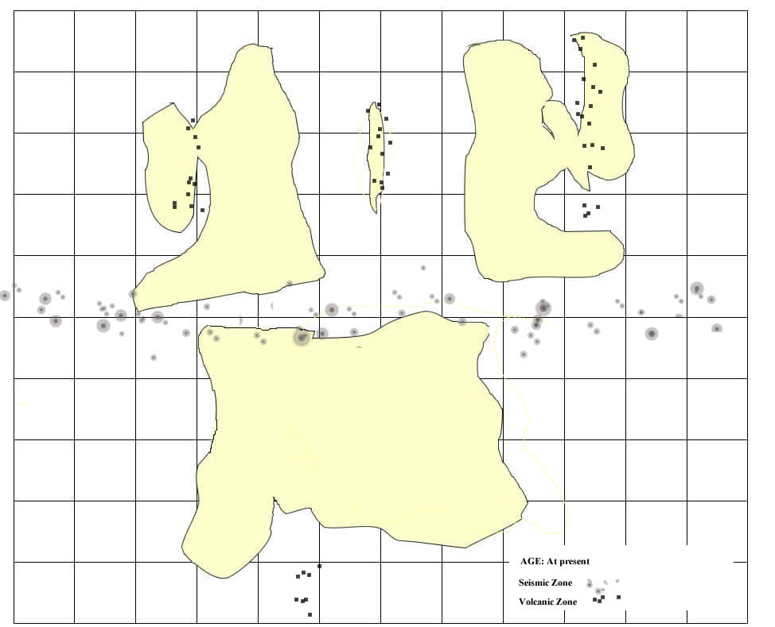
From the evidence...  (description, situation and identification of evidences) | We conclude that probably...  (what these evidences suggest or indicate) | And so...is...because/even if...also/but... (implications for the general model and connection to other evidences )
What remains unexplained...It is still to be known... (new questions arising from your conclusions, which kind of data could help you to solve it)

