Worksheet Paleomagnetism

When igneous rocks are formed, its cristals get arranged following the magnetic field of the Earth.
As the magnetic north of Earth has been changing over the time, the age of some rocks (mainly rocks from the oceanic crust) has been calculated by using the paleomagnetic orientation of its cristals, thus allowing to stablish sequences in the generation of this kind of rocks.
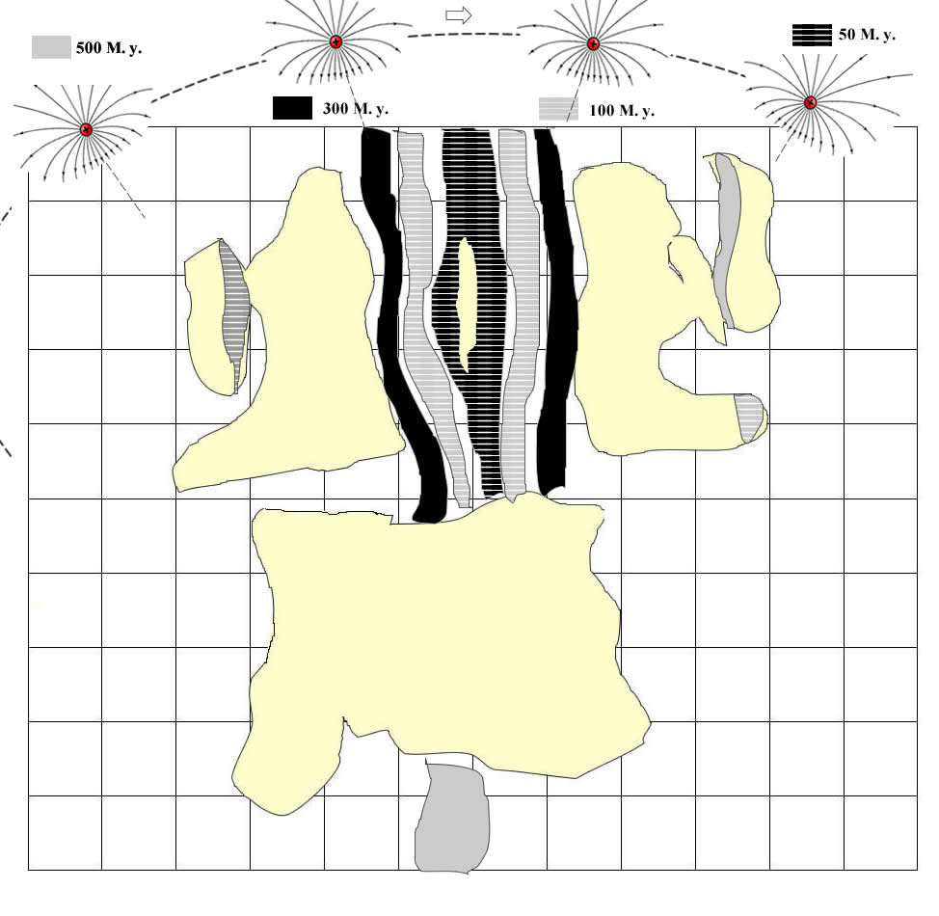
From the evidence...  (description, situation and identification of evidences) | We conclude that probably...  (what these evidences suggest or indicate) | And so...is...because/even if...also/but... (implications for the general model and connection to other evidences )
What remains unexplained...It is still to be known... (new questions arising from your conclusions, which kind of data could help you to solve it)

