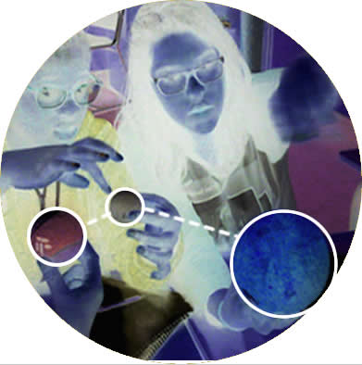

Howlin' Wolves

Constructing an Astronomic Observation Event

Contents
Welcome to Howlin' Wolves. 3
Step 1. Which are the best days to observe the Solar System Planets? 4
Step 2. Which are the best days to observe the Moon? 10
Step 3. Which Constellations will be visible? 14
Step 4. Why Astrology is a “Fake” Science (PseudoScience) 17
Step 5. Preparing the event 19
Step 6. Glossary 20
Calendar 23
Assessment 25
Credits, Licenses and Didactic Guide 26

Name......................................................................................................................................................................

Version: 19/07/19

Welcome to Howlin' Wolves

Read and Understand
In this activity, your goal is to prepare an Astronomic Observation Event: stablish the date and hour we should observe the sky with a telescope, which astronomic objects we could see, and where should they appear in the sky. You will invite someone (your father, a friend, your brother, your grandmother,...) to perform the astronomic observation you will prepare. To do so, in this activity you will learn about the solar system, its planets and moons, and its movements and build an Observation Calendar. You will follow several steps, and at each step you will get new information to include in your calendar. In this Steps you will be asked to Discover (Learn new things), Apply (use the thing you learn to prepare the Event) and Connect (establishing relationships between observable phenomena and scientific models we use to explain it). At the end of this guide, you will find some pages where you are asked to build your Glossary along the activity. There is also an Assessment section where you are asked to keep control of your progress. Use this guide to follow the steps and make the underlined tasks.

- Get familiarised with this guide. To do so, write your name in the front page, and answer the following questions:

a) In which pages is the Glossary Section? ….....................................................

b) In which pages are the Calendar Frames? …...................................................

c) In which pages is the Assessment Section?........................................................

d) In which pages can we find links to videos? …................................................

e) Give a translation for the following terms and identify at least 2 pages where they appear:

Discover......................................pages......................................
Apply...........................................pages......................................
Connect......................................pages......................................

2. In this project, you will learn about Solar System planets, the Moon and Constellations. Write down what you know about it, and compare your notes with your classmates.

3. Write here which is the goal of this activity:

…...................................................................................................................................................................................

Step 1. Which are the best days to observe the Solar System Planets?

Read and Understand
In this section you will Discover how planets move, why they appear and disappear from sky. You will Apply it to set the best days/hours to observe planets in your calendar.

4. Discover. Why and how some planets are visible and others aren't. Look and comment the following videos, and include in your Glossary the main astronomy vocabulary terms about planet movements in Solar System.

Video 1: https://www.youtube.com/watch?v=4yzraWw8mrc
Video 2: https://www.youtube.com/watch?v=z8aBZZnv6y8
Video 3: https://www.youtube.com/watch?v=0jHsq36_NTU

5. Discover. Complete this “orbital map” by lacating and naming each planet.
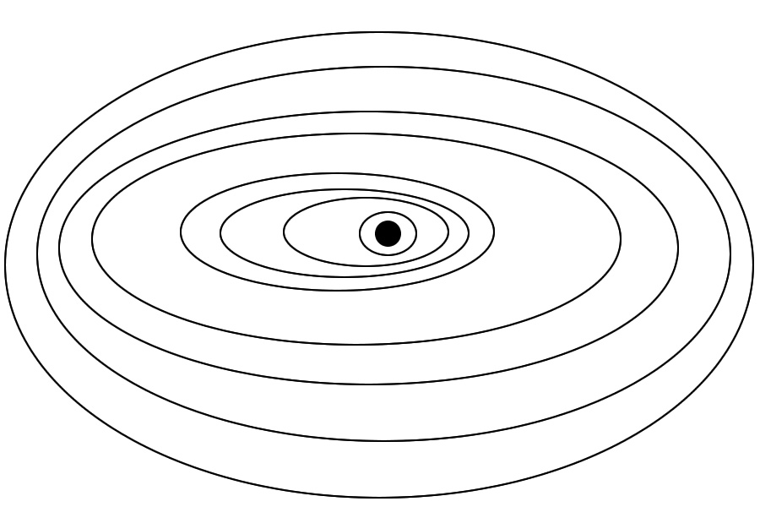

6. Step 3.-Apply. Open the Stellarium program. Take a look at the buttons and analyse its functions. Play for a moment with the program. Make a drawing of the main screen and take notes about the functions of each button.

7.-Apply. Get an agreement about the calendar frame. When are you expecting to perform your observation? Set the dates of the Calendar Frame (2-3 months).

8.-Apply. Make a selection of the dates and hours where we could see at the same time Jupiter and another planet with a telescope. Change the dates with the buttons and Mark all the suitable dates in the main calendar.

Take into account that:
-Only the planets Mars, Venus, Jupiter and Saturn are visible with a common telescope.
-Usually, only very early in the morning or late at the evening, planets are visible.

9. Connect the expected position in the sky with its position in the Solar System orbits. Select 3 of the dates and hours you propose (one in the evening, two in the morning).
Complete three “orbital maps” and for each of these, note the Date, Hour and the position of the planets in their orbits interpreted from what you see at Stellarium. Draw also the expected sky position from the observer, the cardinal orientation (N, S, W, E), the main constellations, and the Ecliptic. Take into account the orientation of Earth in its Rotation movement.

Date.....................................Hour.........................

Design here the Ecliptic and the position of the planet.

Date.....................................Hour.........................

Design here the Ecliptic and the position of the planet.

Date.....................................Hour.........................

Design here the Ecliptic and the position of the planet.

10. Connect. Why it is not easy to see Mercury, Neptune or Uranus? Draw an Orbit map to justify your results, and write three sentences to explain it. Take into account that: a) The more distant a planet is, the lower is the light we receive from it. b) -We can see the planets and stars only during the night, as during the day the light of the Sun does not allow to see the stars nor planets.

Because...As a consequence...So...

11. Discover. Look and comment the following videos, and make a list of the main astronomy vocabulary terms about structure and sizes in Solar System.

Planet sizes: https://www.youtube.com/watch?v=At0w3pnIVgc
Distances: https://www.youtube.com/watch?v=BT49AiYFV98

12. Construct. Make a table with the planets in the Earth System. One row for each. Include in the table their distance from the Sun (in km and AU), and their diameter (in km). Calculate in each case their distance and size assuming that the whole Solar System (40 AU) is 10 km length.

 | Distance from the Sun |  | Distance in a 10 km-length Solar System | Diameter | Diameter in a 10 km-length Solar System
 | Km | A.U. |  | Km | cm
Mercury
Venus
Earth
Mars
Jupiter
Saturn
Uranus
Neptune

13. Observe the 4 “Orbit maps” you have drawn. Discuss in 4 sentences what in these maps is not correct.
Because...As a consequence...So...

Step 2. Which are the best days to observe the Moon?

Read and Understand
In this section you will Discover how the Moon moves, why is its shape changing, and you will Apply it to set the best days/hours to observe the Moon in your calendar.

14. Discover. Why and how Moon changes its appearance and position Look and comment the following videos, and make in the Glossary a list of the main astronomy vocabulary terms about planet movements in Solar System.

Moon phases exist: https://www.youtube.com/watch?v=3f_21N3wcX8
Moon phases have a relationship with Moon orbit.
https://www.youtube.com/watch?v=J9o2OVbdyRM ;
https://www.youtube.com/watch?v=IqhnU87mGpo ;
https://www.youtube.com/watch?v=wz01pTvuMa0

15. Discover Complete 3 Different drawings of the Moon-Earth-Sun system representing the Moon phases, Drawing the Moon positions and the position of the observer on Earth.
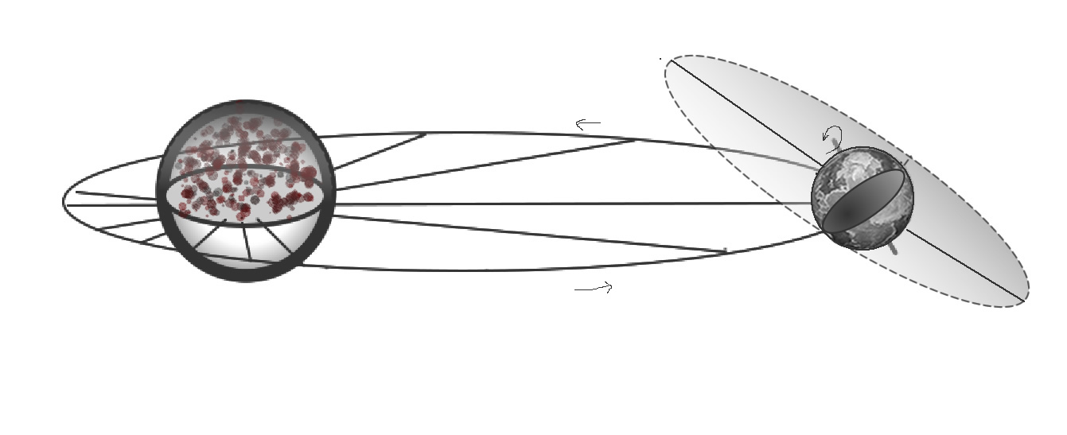

16. Apply. Look into a Moon Calendar the Moon Phases in the selected Calendar Frame. Use Stellarium to determine the best days and hours to observe the Moon with a telescope. Take into account that the best Moon phases are when Moon is at its half, as shadows of the craters make it easier to see them. Complete the informations in your Calendar.

17: Connect. Make drawings of the Moon-Earth-Sun, representing the position of the Sun-Earth- Moon in the dates you selected in your calendar for Moon Observation. Note for each drawing the date and hour. Next to each drawing, include also a Drawing for the shape the Moon will show seen from Earth.

18. Discover. Look at these videos about Eclipses and include the main astronomy vocabulary terms about Solar and Lunar Eclipses in your Glossary

Solar Eclipses
https://www.youtube.com/watch?v=Qog18tiNnqg&t=4s
https://www.youtube.com/watch?v=XNcfKUJwnjM

Lunar Eclipses:
https://www.youtube.com/watch?v=wuhNZejHeBg
Min 1:30 : https://www.youtube.com/watch?v=lNi5UFpales
Min 1 https://www.youtube.com/watch?v=wHxcWSiD_4E

19. Construct. Draw a Sun-Earth-Moon orbital map as the previous ones displacing the earth along its translational orbit until a Solar or Moon eclipse is possible. Identify it and represent it.

20. Connect. Make a search in internet to stablish the dates of the next Solar and Lunar eclipses from your location. Make a list of 4 eclipses and note its dates. Represent it in as a Sun-Earth-Moon orbital map taking into account also the dates (Earth is nearest to the Sun in winter).

Step 3. Which Constellations will be visible?

Read and Understand
In this section you will Discover what are constellations and why we cannot see them all the time. You will Apply it to stablish which constellations will be visible in you Astronomic Observation, and you will study the stars forming one of these constellations.

21. Discover. Look at these videos about Constellations and make a list of the main astronomy vocabulary terms about Constellations in your Glossary.

https://www.youtube.com/watch?v=IwRIu76TY-k

22. Apply. From the dates selected in your calendar (when planets and Moon will be easily visible), stablish with the help of Stellarium which 5 constellations will be easily visible at this time frame Make a list and a drawing representing it. Write down also the date, hour and cardinal orientations (NWES).

23. Connect. Draw the Earth seen from the Sun with the observable constellations backward in the selected date and hour. Delimitate which constellations on the backward will be observed in the following time frames: 1) 4 hours before 2) at observation time 3) 4 hours after, as Earth rotates.

24. Construct. Select one of the visible constellations from Stellarium. Make a table with the name of each star, its kind and distance in Light Years. Make a Drawing representing approximatively (Accordingly with its distance), the constellation in 3D, as in the following example. Identify each star in the graphic.

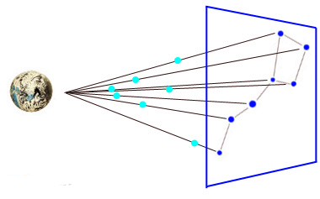

Step 4. Why Astrology is a “Fake” Science (PseudoScience)
Read and Understand
You may have heard about Astrology: it's a mythic conception that considers that the respective position of Earth, Sun and Constellations have some kind of magic power to predict your character, abilities, and future. This conception has no scientific basis and its failure has been demonstrated thousands of times.
Constellations located in the projection of the Ecliptic are periodically situated backward the Sun when seen from Earth. Astrology believers consider that this position (a determined constellation “housing” backward the Sun) at the moment of a person's birth, would in some way (?) determine one's character, personal skills and future. The call it Horoscopes signs (Piscis, Cancer,...) on behalf of which constellation “houses” backward the Sun.
Astrology believers have failed to propose an explanation about the means this position of the constellations would have such effects.
However, in this section we will take a look at its basis: Astrology believers claim that one's astrological sign (Piscis, Cancer, ...) is determined by which constellation is situated backward of the Sun at your birth date. We'll make an experiment to test the Horoscope Signs atributions.

25. Discover. Look in newspapers or internet for actualized horoscope predictions of an Horoscope sign. You will need at least 3 different predictions. Organize the informations given in a table as follows, put in common your results with your classmates, and answer: are these predictions consistent?

Sign:  …..................................... | Money | Health | Love
Prediction 1
Prediction 2
Prediction 3

26. Discover. Look into internet for descriptions of the characters or abilities depending on the Horoscope sign. Read it in loud voice in the classroom identifying each description with a number. Ask each classmate to identify him/herself with one of the descriptions. Read again the descriptions, this time identifying the horoscope sign. State how many people were correctly described and calculate the % success rate:

Consistents (horoscope sign coincident with the selected description): .............................. students
Not Consistents (horoscope sign not coincident with the selected description)................. students

% success rate= (Consistent / Total) x 100 = …........................................................................................

27. Discover. Look for an astrological calendar and identify from your birth date which would be your astrological sign (Pisces, Aquarius, ...). Note your astrological sign: …............................................

28. Connect. Open the Stellarium program and get back to your birth date. Advance until you can see the sun. Eliminate the atmosphere so you can see the constellations backward the Sun. Make a Drawing of the result, identifying the constellations names.

29. Apply. Identify which constellation were situated backward the Sun when you where born. Does it fit with your Astrological Sign? Does it fit for all of your classmates? Note the success rate of the persons in the classroom having Astrological signs coincident with the Astronomic position.

Connect. Explanation: The translation movement of Earth does not fit exactly with the calculated 365-366 days. Earth performs also other movements, as precession, that changes along centuries the respective positions or Earth, Sun and Constellations. As Astrology is not a scientific knowledge -but a myth-, it hasn't been actualized during centuries. During these centuries, the position of Earth in relationship to the Sun and the constellations has changed, so the position of the Sun on a constellation in a certain day of the calendar (“Housing”) is not the same as it was centuries ago. As a result:

Not only Astrology fails to make certain predictions, (No Scientific Law)
Not only Astrology fails to explain why should it work, (No Scientific Theory)
But also Astrology construct its myths on positions of the Celestial bodies that are no longer true.

Step 5. Preparing the event

Read and Understand
Now you have completed your Calendar, and should choose a day for your observation. Once you have decided the day and hour of your observation, you will prepare a triptic for your invitee.

30. Construct. In the triptic, you have to welcome him/her to the Howlin'Wolves Astronomic Observation and explain accurately which objects will be observed, its position and its relationship with Earth's movements rotation and translation. Distribute the informations in sections and include images you would need to explain him/her what they are seeing during the observation. You must use at least half of the selected vocabulary terms of the activity.

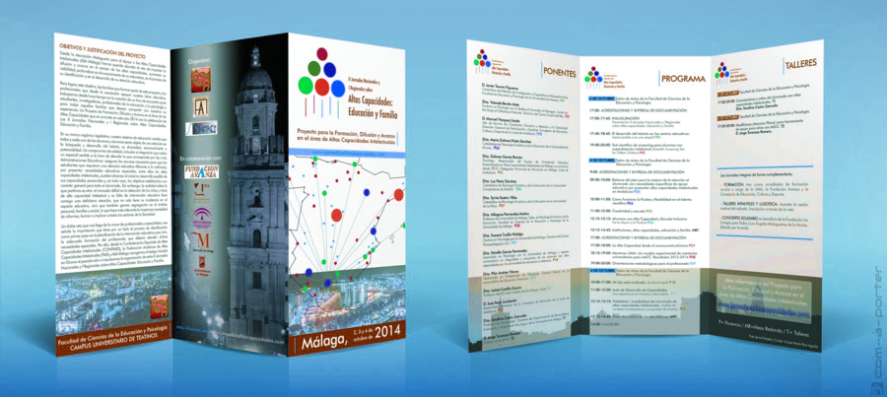

Step 6. Glossary

Construct here a conceptual map with the Glossary Terms

Calendar

Month.....................................................

Month.....................................................

Month.....................................................

Month.....................................................

Assessment

I completed correctly the steps...  Assess with your team mates if you have completed and were actively engaged on each of the Steps of the activity. | /10
Step 1
Step 2
Step 3
Step 4
Step 5
Step 6
Calendar
GLOBAL/10

I consider I have learn... | /10
GLOBAL/10

I consider I have been able to transfer my learning to my final product | /10
GLOBAL/10

Taking into account what How much I have worked on this project, How much I have learn on this project and How able have I been to transfer my learning to a final product, I mark my activity as:

............../ 10
To improve, I should...

Credits, Licenses and Didactic Guide
<<YOU DON'T NEED TO PRINT THIS PART ON YOUR STUDENT'S MATERIALS>>

Didactic Guide

This activity is directed to 12-years old 1 ESO Science students. The goal of the activity is to prepare an Astronomic Observation Event. This dossier and all the materials needed to perform the activity are available at: https://sites.google.com/site/projectantbiogeo1/howlin-wolves

This activity has been included in two collections of “active methodologies” ressources:
Astrono-me, a collection of activities to teach astronomy : https://sites.google.com/site/astrono2me/home
ProjectantBioGeo1, a collection of activities to teach the Science syllabus of 1 ESO: https://sites.google.com/site/projectantbiogeo1/home

In the activity students follow several steps where they learn concepts of Astronomy (ecliptic, orbit, satellites, constellations, and different kinds of astronomic objects). Each step of the activity includes Discover (students learn new concepts), Apply (using concepts to develop the goal of the project: the Astronomic Observation Event) and Connect (structuring the knowledge). Step 4 of the activity is optional and can be eliminated from the activity.
You are strongly recommended to effectively perform with your students the Astronomic Observation they prepare, so a Telescope is needed. The activity has the aim to connect with the cultural side of Astronomic Observation, so is defined as an Observation Event students prepare for someone of their family or friends, their invitee. This is a key aspect of the activity, as transform students to Science Disseminators.
The activity does not include the usual mythologic references to constellations (Ancent Greece Legends), as I consider this reinforces the conception of constellations as “plate” drawings in the sky instead of tridimensional systems, and usually includes misconceptions, as giving intentionality to constellations position or movements. You can add it if you can, but I advise against it.
As Stellarium includes also Galaxies and Artificial Satellites, the activity can be further developed to include these astronomic objects.
A part from the Telescope, materials needed to perform this activity are: Computers with the Stellarium program installed (one for each couple of students). Balls of different sizes to model the movement and positions of celestial bodies. Classrom computer connected to internet and a projector.
There are not guidelines for the final product (the triptic for the Astronomic Observation Event) a part from the use of vocabulary terms. Each teacher should conduct this from his/her own views and standards. The assessment Section is to be completed by students at the end of each session. There is also an assessment scaffold for the final product that includes an optional second assessment to give students the opportunity to improve their work from the first assessment.This activity takes 10 hours to be completely developed by students. Students can work in couples, but has to complete their own Observation Guide and construct their own Triptic.
An article describing the design and results of the application of the activity is available in Spanish at:
Howlin’ Wolves: un proyecto de astronomía para conectar la observación, el modelo científico y la experiencia cultural. Alambique, Didáctica de las Ciencias Experimentales, 95, 53-58. Jordi Domènech-Casal. https://wp.me/p25seH-yj

The activity is also described in a more general text describing Project-Based Learning (PBL) available in Catalan:
Aprenentatge Basat en Projectes, Treballs pràctics i Controvèrsies. 28 experiències i reflexions per a ensenyar Ciències. (2019). Rosa Sensat: Barcelona. Jordi Domènech Casal. https://wp.me/p25seH-DC

Stellarium program Free Download: http://www.stellarium.org/ca/

Catalan Syllabus links (attending the official syllabus as published in Decret 187/2015 DOGC núm. 6945 – 28.8.2015)

Biologia I Geologia 1 ESO

Continguts

L’Univers i el sistema solar (CC4, CC16)
o Observació del cel nocturn i diürn. Diferenciació entre galàxies, estrelles i planetes.
o El sistema solar. Dia i nit, estacions, fases lunars i eclipsis.
o Geocentrisme i heliocentrisme com a dues explicacions històriques per situar la Terra a l’Univers.

Criteris d'avaluació

1. Plantejar preguntes que possibilitin la descripció d’un fenomen o d’un ésser viu, a partir de l’observació sistemàtica i la identificació de variables.
2. Elaborar informes sobre el treball realitzat, fent servir amb precisió el vocabulari pertinent.
3. Posicionar el Sol, la Terra i la Lluna per explicar el dia i la nit, les estacions, la durada del dia al llarg de l’any, les fases lunars, els eclipsis i la longitud de les ombres.

Competències Científico-Tecnològiques

Competència 2. Identificar i caracteritzar els sistemes biològics i geològics des de la perspectiva dels models, per comunicar i predir el comportament dels fenòmens naturals.
Competència 4. Identificar i resoldre problemes científics susceptibles de ser investigats en l’àmbit escolar, que impliquin el disseny, la realització i la comunicació d’investigacions experimentals.
Competència 6. Reconèixer i aplicar els processos implicats en l’elaboració i validació del coneixement científic

Credits and Licenses

This activity has been developed by Jordi Domènech-Casal, teacher at Secondary Education Institute “Institut Marta Estrada” (Granollers, Barcelona, Spain). https://jordidomenechportfolio.wordpress.com/ | jdomen44@xtec.cat | @jdomenechca

This activity is shared under a Creative Commons License NoCommercial-ShareAlike 4.0. You are free to. Share, Transform with no commercial purposes, citing the original author. This activity has been build and shared for non-profit educational purposes. Images are excluded from this general License and may have its own CopyRight license.

