Site Grid ................................................................ Authors.................................................................................................................................
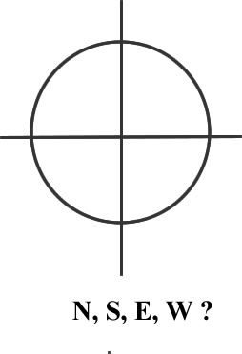
A B C D
Be sure to include in your frame: 1) the references for the information you are giving (books, webs) 2) the funcional implications of these evidences (“This kind of tool means that this species was able to...”).

